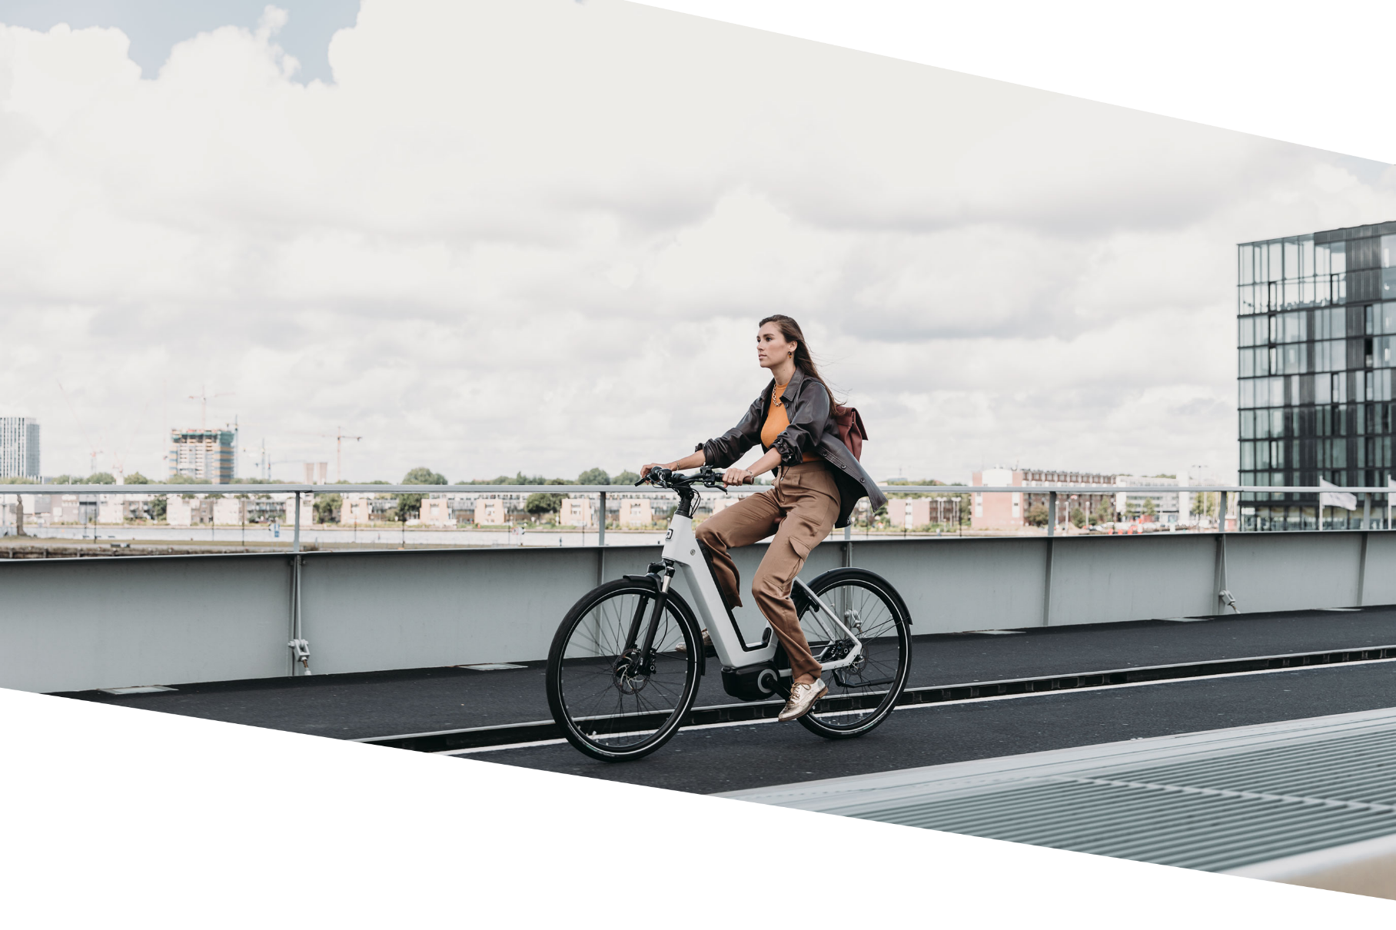

Bicycle scheme

[Name of employer]

**title DOCUMENT**

**on 3 lines   
max**

Subtitle

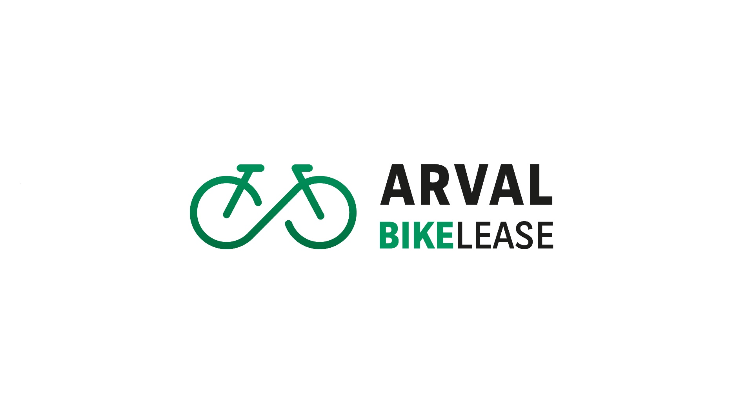

Version number: version number

Effective date : effective date

[Datum]

# Instructions (Delete this page)

In several places in this document, the term [Name of employer] must be replaced by your own company name. Use Ctrl + F to find and replace the term quickly and easily.

* The parts highlighted in green can be changed based on the policy decisions your company makes.
* The parts highlighted in yellow provide more information about the policy decisions to be made and serve as a guide to help you set up your new or updated bicycle scheme.

This document has been compiled with great care. It is the responsibility of the employer to review this document, either internally or externally, for enforceability and clarity.

Once all the changes have been made to this document, you can save this version as a PDF and this scheme can then be uploaded to your own employer portal on our Arval Bike Lease platform (under the Documents tab 🡪 Bicycle Lease Scheme).

During the ordering process, the employee must agree to this scheme. Once the lease starts, the platform will send a digitally signed copy to the employee and the employer. Do not launch the bicycle scheme before the entire bicycle lease scheme has been correctly uploaded to the platform!

This page and all the text highlighted in yellow can be deleted as soon as you have finalised this document.

**END OF INSTRUCTIONS**

# Introduction

It is with great enthusiasm that we as [NAME EMPLOYER] introduce our bicycle scheme! Why did we introduce a bicycle scheme? The answer is simple: we believe in a healthy and happy working environment, where our employees feel valued and can easily contribute to a more sustainable world. Our aim is to boost our employees' health, reduce CO2 emissions and improve mobility at the same time.

By choosing to cycle, we reduce our carbon footprint and actively contribute to reducing air pollution. This initiative is an essential part of our commitment to sustainable business and environmentally conscious operations.

In addition, cycling has of course a proven positive effect on our health. It encourages exercise, contributes to a healthy weight and improves overall fitness.

Moreover, we believe that offering a cycling scheme makes us more attractive as an employer to potential new employees.

We hope you will be excited to participate in this initiative and work together towards a healthier and more sustainable future.

To make this bicycle scheme possible, [NAME EMPLOYER] has entered into a partnership with Arval. Arval has a nationwide network of affiliated bike dealers and a fully digital platform where you have the freedom to choose almost any brand of bike. From e-bikes to (e-)cargo bikes, and more!

By starting a lease contract, you agree to this policy and acknowledge that you are aware of the terms and conditions regarding costs in case of early termination of the contract. In this document, we explain how the bicycle plan of [NAME EMPLOYER] works. Any questions or ambiguities can be discussed with the HR department.

We sincerely hope that you will participate in this initiative and enjoy using the bicycle scheme.



SUBSCRIBE?

CLICK HERE!



***EXPLANATION****: Add to the above button the link to your exclusive subscription page. You will receive the link of this page before the start date of the bike lease scheme at your organization.*

# Bicycle lease scheme

1. **Who may participate in the bicycle lease scheme provided by [NAME OF EMPLOYER]?**
   1. This scheme applies to all employees, apart from those in their probationary period, who have
      1. a permanent contract
      2. a temporary contract
      3. [Add any other conditions]

***Instructions****: Enter details of employees who are entitled to use the bicycle scheme. You can also add employees on temporary contracts; employers with many temporary employees do this. There is no financial risk for the employer as the costs of terminating the lease contract early (40% of the remaining lease terms) can be charged on to the employee. All employers do this to prevent an employee from taking part in and leaving the scheme on a whim and it also creates additional commitment. The employee can then return the bicycle free of charge or take advantage of the optional buy-out offer.*

* 1. You are not eligible for this bicycle scheme if you:
     1. work fewer than 12 hours per week
     2. have a zero-hours contract
     3. [Add any other conditions]
  2. You may lease a bicycle if you also have a lease vehicle.
  3. You may lease a maximum of [X] bicycle / bicycles per 36-month contract term.  
     ***INSTRUCTIONS****:* *It is possible to lease more than 1 bicycle, and we see that some employees also want to purchase a bicycle for their partner or children via the lease structure. This is also permitted, although, as the employer, you may want to set additional requirements by, for instance, limiting the maximum to 1 bicycle.   
     Moreover, the taxable amount of 7% must be paid for each lease bicycle separately and we recommend that an additional (employer’s) contribution is applied to the total amount only. For each lease bicycle, you must apply the cost-neutral (employer’s) contribution of EUR 25. If you provide an additional (employer’s) contribution on top of this, but your employee wants to lease several bicycles, only provide the additional (employer’s) contribution once and not for every lease bicycle.*

1. **What kind of bike can you choose?**
   1. You can choose from the following types of bicycles:
      1. e-bikes,
      2. normale (city) bikes
      3. e-cargo bikes
      4. speed pedelecs
      5. sportive bikes (race bike and mountain bikes).  
         ***EXPLANATION****: we provide all possible types of bicycles. Some employers choose to exclude certain types of bicycles. You can remove some types from the list, but you don’t have to.*   
         You can choose from over 100 top brands such as Batavus, Koga, Gazelle, Urban Arrow, Cowboy, Veloretti, Giant, Trek, Qwic, Stromer, Cortina, Riese & Müller, and many more!
   2. Choose a bike as follows:
      1. Through one of the affiliated Arval bicycle dealers. See the [list of online dealers](https://www.arval.nl/mobiliteit/bike-lease/dealers) for a dealer near you.
      2. Through the [online catalogue](https://www.arval.nl/mobiliteit/bike-lease/aanbod#/), provided your chosen bike can be ordered online. This is indicated by the ‘Order online’ label:  
           
         
   3. You can choose a bicycle without a maximum / with a maximum rental price of EUR XXX,- per month.   
      ***INSTRUCTIONS****: use the* [*calculator*](https://www.arval.nl/mobiliteit/bike-lease/calculator) *to calculate the maximum rental price per month. This is shown on the Total rental price line. Most employers leave this blank or choose a maximum rental price of EUR 175 = EUR 5000 RRP incl. VAT. Employers who set a maximum rental price do so because they are unsure whether employees can handle the responsibility. You can also choose to set budget groups to have a suitable offer for all employees. Note: The PIN code will not work if an employee chooses a bicycle above the maximum rental price.*
   4. You may lease a maximum of [X] bicycle / bicycles per 36-month contract term.  
      ***INSTRUCTIONS****: It is possible to lease more than 1 bicycle, and we see that some employees also want to purchase a bicycle for their partner or children via the lease structure. This is also permitted, although, as the employer, you may want to set additional requirements by, for instance, limiting the maximum to 1 bicycle.   
      Moreover, the taxable amount of 7% must be paid for each lease bicycle separately and we recommend that an additional (employer’s) contribution is applied to the total amount only. For each lease bicycle, you must apply the cost-neutral (employer’s) contribution of EUR 25. If you provide an additional (employer’s) contribution on top of this, but your employee wants to lease several bicycles, only provide the additional (employer’s) contribution once and not for every lease bicycle.*
   5. You will receive an extra ART-2 approved chain lock from the dealer and if you choose a speed pedelec, you will also be given a helmet. This is a requirement imposed by the insurance company. These accessories are already included in the monthly rental price.
   6. You can also include accessories in the lease contract.
2. Accessories need to be mounted to the bicycle. For example: pedals, a saddle, panniers or a bench in a cargo bike. You can buy separate accessories such as a raincoat or a bike computer yourself through the affiliated dealer, but can not be included in the lease contract.
3. Accessories can be added during the order process. Afterwards, no accessories can be added.
4. The total amount for accessories is a maximum of 15% of the consumer price of the bicycle.

***INSTRUCTIONS:*** *The total value of accessories may never exceed EUR 745. As an employer, you can also express this in a maximum percentage.*

1. **How much does it cost to lease a bicycle via [NAME OF EMPLOYER]?**
   1. To find out what your monthly (net) lease costs will be, use our handy [calculator](https://www.arval.nl/mobiliteit/bike-lease/calculator).

Enter the bicycle type, the brand, the value of the bicycle, and the employer’s contribution (if applicable). The calculation shows the gross monthly lease costs, the taxable amount, the tax payment, and the final net monthly expenses. The net costs are deducted from your salary.

Scroll down further to the second section to see an overview of the costs you will save compared to buying a bicycle. Here, you will also see the estimated take-over price for taking over the bicycle at the end of your lease contract.

* 1. [NAME OF EMPLOYER] will pay a monthly amount of EUR 50,00 / [x]% of the monthly rental price, including VAT (the ‘employer’s contribution’) during the entire duration (36 months) of the lease contract.  
     ***INSTRUCTIONS****: enter the amount of the employer’s contribution here. Most employers opt for a contribution of EUR 50 per month. Please note: this is a gross amount and will therefore cost you less as an employer than you would expect. If you pay EUR 50, the actual costs are only EUR 32 because you still save on employers’ social security contributions.*
  2. [NAME OF EMPLOYER] will also give you back the VAT benefit and that amount is discounted in the monthly employer’s contribution.   
     This is included in the [online calculator](https://www.arval.nl/mobiliteit/bike-lease/calculator) as standard. You therefore need to slide the toggle to ‘off’ for ‘VAT included?’  
       
       
       
       
     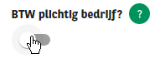
  3. It is possible to set off up to a maximum of X days of holiday in excess of the statutory minimum (of 8 hours) against the lease term. Indication of the gross hourly wage can be found on the pay slip.

Example calculation: use of 6 holidays * 8 hours * EUR 30 gross hourly wage = EUR 1440. EUR 1440 / 36 months results in EUR 40 additional monthly employer contribution.

In case of termination of employment during the lease period, the 'balance' of the extra employer contribution (obtained from the use of holidays in excess of the statutory entitlement) is offset against the early termination payment.

***Explanation:*** *the employee declares to HR how many hours he wants to sell in exchange for an additional employer contribution. He does this when the choice for a bike has been made. HR calculates the contribution and fills in the extra monthly contribution in the tool when approving the order. Do not forget to also make these changes in personnel administration.*

* 1. The monthly lease amount, including VAT and minus the monthly employer’s contribution, is the amount that you pay for the lease bicycle. This amount will be deducted from your gross salary during the lease contract term.
  2. The monthly lease amount may be changed before the bicycle is delivered. This may be the case if there are changes in the consumer price of the bike or accessories in the meantime. This change is passed on in the amount you pay monthly.
  3. Any reduction in gross salary does/does not affect the accrual of holiday pay and pension accrual and does affect the amount of any social security benefits (such as unemployment benefit and sickness benefit), severance pay, and the taxable (annual) income.  
     ***EXPLANATION****: To offset the consequences of a decrease in holiday pay and pension, a wage component needs to be created in the payroll administration to take care of deductions from the gross wage for the lease bicycle. This ensures that the holiday pay and pension do not decrease along with the gross wage. If you are unable or unwilling to do so as the employer, then the holiday pay and pension will decrease along with the gross wage.*
  4. If you fall below the set statutory minimum (collective agreement) wage because of a reduction in gross pay due to the deduction of the lease costs, you will unfortunately not be eligible for a lease bicycle. [NAME OF EMPLOYER] will verify this for you once you have placed an order.
  5. As an employee, you are subject to tax for private use of the bicycle; this is known as the taxable amount.   
     This is an amount that is added to your *gross salary* and is subject to income tax. The taxable amount is 7% of the recommended retail price of the bicycle and accessories (including VAT) per year. Since you pay the taxable amount, you may always make unlimited private use of the bicycle. This also means that you do not have to use the bicycle to travel to and from work. If you live too far from the office, the bicycle scheme may still be an attractive option for you as you can use the lease bike for private use.
  6. When you lease a bicycle, this is not recorded with the Dutch Credit Registration Office. This is because you lease the bicycle via your employer and do not therefore take out a personal loan or enter into a credit agreement.
  7. If you receive a net travel allowance for commuting, you will not receive this travel allowance for the days (or kilometres) you use the lease bike for commuting. Instead, [NAME OF EMPLOYER] will provide a gross mileage allowance of EUR 0,17 cent / give back the loss in travel allowance via the employer’s contribution. This means you will receive a higher contribution from [Name of employer] which will lower your monthly lease costs.  
     ***INSTRUCTIONS****: we advise you to think carefully about reinvesting/compensating for the possible loss of travel expenses (this only applies to employees who receive a travel allowance, which may be a limited group). This will increase uptake of the bicycle scheme. We have noticed than when the loss in travel expenses is not compensated, there is little to no enthusiasm for the bicycle scheme. When the loss of travel expenses is compensated, there is a significant increase in the uptake of the bicycle scheme. In addition, you encourage employees to travel to and from work by bike.*

*Do you want to know more about this? Such as how to arrange the travel allowance without a large amount of additional administrative work?* [*Visit our help centre*](https://help.hellorider.com/ik-ben-een-werkgever)*.*  
If you want to know what this means for you, open the online calculator and switch on the toggle for ‘Account for travel allowance in calculation’:  
  
  
  
  
  
  
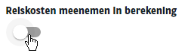  
You keep your net travel allowance for the days on which you do not use the lease bike for commuting and travel to work using your own transport, for example.

1. **Use of the bicycle**
   1. You may not use the bicycle for commercial purposes (e.g. parcel delivery or rental).
   2. However, you are permitted to occasionally allow family members or friends to use the bicycle. They, too, may not use the bicycle for commercial purposes (e.g. parcel delivery or rental).
   3. You are required to handle the bicycle with care. This means that you must always lock your bicycle (even in your own garage), place the battery in the holder on the bike and close the lock of the battery (so that the battery is anchored to the bicycle) when leaving your e-bike unattended, and must not cause intentional damage to the bicycle.
   4. You may use the bicycle for private purposes. You are not obliged to use the bicycle for commuting to work.
   5. For repairs and servicing, please contact one of Arval’s affiliated dealers. You can find them on Arval’s website (<https://www.arval.nl/mobiliteit/bike-lease/dealers>).  
      For repairs and servicing of a Veloretti or Cowboy, please contact Hellorider’s Customer Service department via [www.hellorider.com/contact](http://www.hellorider.com/contact).
2. **Other costs you have to pay as an employee**
   1. As an employee, you will be charged the following costs:
      1. All costs in relation to accessories that are not part of the lease contract
      2. Costs due to careless use of the bicycle
      3. Damage costs not covered by insurance
      4. Damage caused by insufficient maintenance or abnormal wear and tear
      5. Damage caused by during competitions or preparations for them
      6. Damage caused during drunkenness, drug use or use of medicines that affect traffic participation
      7. Damage cause by use on unpaved road that are not designated as cycling paths
      8. The excess under the insurance policy
      9. Costs relating to loss due to culpable conduct (e.g. when the employee does not take over the bicycle or return it when the contract ends); and
      10. Fines or other levies (such as public transport costs: ferry costs, train ticket for the bike, etc.) that the employee needs to pay.
   2. [NAME OF EMPLOYEE] is not liable for any damage you suffer as an employee related to use of or (temporary) inability to use the bicycle.
3. **Insurance, roadside assistance, and servicing**
   1. The bicycle is insured for theft and damage with a limited excess. If you choose a speed pedelec, third-party insurance is also included.
   2. An excess of EUR 50,00 is payable by the employee in case of damage and theft (also when it concerns an accessory).
   3. In case of damage, you must report this to Arval as soon as possible, but not later than two working days after it has been noticed. Arval will take care of the settlement of the claim, after deduction of the excess. Reporting can be done by filling in the damage claim form and submitting it via [info@hellorider.com](mailto:info@hellorider.com) or by drawing up a damage report at and affiliated bicycle dealer.
   4. Has your bicycle or have parts or accessories been stolen? You must report this to the police. Always keep the two original keys.
   5. Lost a key and made a copy? Always report this to Arval.
   6. If the bicycle is stolen, your lease contract will be terminated. If you want to choose a new bicycle, you will receive a new invitation from your employer and enter into a new lease contract.
   7. In case of a breakdown in the Netherlands, you can use Arval Assistance, provided by the Royal Dutch Touring Club (ANWB). If you break down while travelling, you can call roadside assistance:  
      [0800 - 228881](Tel:%20+318000228881).   
      Tip: Save this number and make a note of your bicycle frame number that is sent to you at the start of your lease contract.
   8. You can take your bicycle to an affiliated Arval bicycle dealer for repairs and servicing. If the bicycle is unavailable for more than 2 working days due to servicing or repairs, you may be able to use a loan bicycle provided by your dealer. For a list of affiliated dealers, go to:  
      <https://www.arval.nl/mobiliteit/bike-lease/dealers>
   9. When the lease contract is nearing its end, Arval may refuse to authorise repairs in order to prevent misuse. For repairs towards the end of the lease contract, the best solution will be considered on a case-by-case basis. Repairs will always be permitted if the dealer deems it necessary for the functioning or safety of the bicycle.
4. **Customer service and contact information**
   1. If you have a question or complaint related to the bicycle that cannot be solved by an Arval dealer, you can contact the Hellorider Customer Service department via [www.hellorider.com/contact](http://www.hellorider.com/contact)
   2. As an employee, you must ensure that Arval always has your contact details (e-mail address and phone number). If your contact details change, you must notify Arval’s Customer Service department yourself via www.hellorider.com/contact.
5. **Duration and termination of bicycle use**
   1. The lease term is 36 months. If you wish to terminate the lease contract early, for example because you are leaving the company, there are three possible options:
      1. You pay an early termination fee to [NAME OF EMPLOYER]. The early termination fee is 40% of the remaining monthly lease terms. These costs are processed in the final settlement as a gross amount when you leave [NAME OF EMPLOYER], which means that you enjoy a gross-net benefit on this termination fee.
      2. You can transfer your contract to a colleague free of charge if they want to take over the bike from you. As a result, you will not be liable for an early termination fee. Your employer will inform Hellorider of the change in good time (before your last day of employment). You must therefore inform your employer as soon as possible of your intention to transfer the lease bicycle to a colleague. It is your responsibility to find a colleague that is interested in taking over the bicycle. You cannot hold your employer liable if you are unable to do so.
      3. You can transfer your contract to a new employer free of charge provided your new employer agrees with this. As a result, you will not be liable for an early termination fee. Your old employer must notify Hellorider of this in good time. You must therefore inform both employers as soon as possible of your intention to take the lease bicycle with you. It is your responsibility to arrange this between your old and new employers. You cannot hold your employer liable if you are unable to do so.
   2. Upon termination of the lease contract, Arval can offer you the option to take over the lease bicycle and accessories. Even when you terminate the lease contract early. The amount of the takeover offer is equal to the current market value at the time your contract ends. After a contract term of 36 months, based on the historical takeover offers to drivers by Hellorider, this is approximately 15%-20% of the recommended retail price.
   3. You are not obliged to take over the bicycle. If you do not wish to accept the buy-out offer, you need to let Arval know by e-mail. You must then return the bicycle to the dealer within 14 days. You will receive an e-mail from Arval with instructions on how and where to return the bicycle.
6. **What you need to do if you want to lease a bike via [NAME OF EMPLOYER]**

If you, as an employee, want to make use of the option of leasing a bicycle via [NAME OF EMPLOYER], the digital process is as follows:

* 1. After registering, you will receive an invitation by e-mail. The invitation contains a unique PIN code to use to order a bicycle. This unique PIN code can only be used once.
  2. There are two ways to order a bicycle:
     1. From a dealer affiliated with Arval. Visit the dealer and ask them for advice or choose the bicycle you would like. Tell the dealer that you can lease a bicycle via Arval and give them the PIN code. The dealer will enter this PIN code in the system and can then order the bicycle.
     2. On the Arval website (<https://www.arval.nl/mobiliteit/bike-lease/dealers>), you can find out which dealers are near you.
     3. You can also order various bicycles straight from the online catalogue. You will need to enter your unique PIN code and can then order the bicycle of your choice provided it is possible to order it online. This is indicated by the ‘Order online’ label.
  3. You will receive an e-mail with the order confirmation for your bicycle, and you will need to agree to the following terms and conditions:
     1. You agree to the monthly lease costs with which your gross salary will be deducted.
     2. You declare that you agree to and will comply with this bicycle scheme (attached to the order confirmation e-mail), and
     3. You provide a truthful estimation of how much you expect to use your lease bicycle per week for business trips and commuting.

***EXPLANATION****: the option to enter use of the bicycle must be configured in the employer’s portal under ‘Settings → Registration of use’. The employee is asked about how much they expect to use their lease bicycle on average per week and provides a truthful estimation. These details are sent via the salary report so that the payroll accounting department knows the number of days for which to withhold any net travel allowance. For more advice, visit the* [*Help centre*](https://help.hellorider.com/ik-ben-een-werkgever)*.*

* 1. Once you have completed step 3, the order needs to be approved by [NAME OF EMPLOYER] and Arval.
  2. Following approval by [NAME OF EMPLOYER], you will receive a notification from Arval as soon as the bicycle is ready to be collected from the dealer or, in case of an online order, when it will be delivered.
  3. When you collect the bicycle or receive delivery of it, a delivery receipt needs to be drawn up. Make sure this is done! Verify that the dealer or deliverer creates this delivery receipt digitally.
  4. The lease contract starts as soon as the bicycle is collected or delivered. You will start paying for the bicycle from that moment onwards.

# Frequently asked questions

## Bike and dealer advice

## At Arval, you can choose from more than 100 bicycle brands at one of the affiliated dealers – from e-bikes and cargo or e-cargo bikes to road bikes, speed pedelecs and more.

## If you are not sure which type of bike (e.g., a city bike, an e-bike, or a speed pedelec) is right for you, you can contact one of Arval’s affiliated dealers for advice. For a list of dealers near you, visit: <https://www.arval.nl/mobiliteit/bike-lease/dealers>

## If you would like to choose a bike from a dealer that is not affiliated with us, please let Hellorider know. Hellorider will then do its best to contact the dealer and arrange this for you.

If you would like to choose a bike from a brand that is not yet affiliated with us, please let Arval know. Arval will assess whether this brand can be added to the range on offer.

## As an employee, what are the costs of leasing a bicycle?

Apart from the type of bicycle and the catalogue value, this depends on your employer’s contribution (if any) that [NAME OF EMPLOYER] has determined and how much you earn. You can use [our calculator](https://www.arval.nl/mobiliteit/bike-lease/calculator) to quickly work out how much a bicycle will cost you per month. You can also calculate how much you would save compared to buying your own bicycle.

## What about the travel allowance?

## You do not receive a tax-free mileage allowance for the kilometres you commute on your lease bike. For example, suppose you work 5 days and you get a monthly mileage allowance of EUR 50,-00. If you use your lease bike to commute to work on 1 day, you will lose

## EUR 10,00 and keep the remaining EUR 40,00.

## 

Your employer may compensate for this loss by providing a gross mileage allowance (instead of a net mileage allowance) or by giving back this loss in travel allowance via a (higher) employer’s contribution which lowers your monthly lease costs. You can see if this is the case for [NAME OF EMPLOYER]’s bicycle lease scheme under the heading: How much does it cost to lease a bicycle via [NAME OF EMPLOYER]?

## What exactly is the taxable amount?

## Anyone who ‘receives’ a company bicycle pays a taxable amount. The taxable amount is 7% of the recommended retail price of the bicycle and accessories (including VAT) per year. Want to know how much you will pay? You can calculate it as follows: 7% * [your monthly gross salary] / 12 = the monthly costs of the taxable amount. You can also calculate the taxable amount using [our calculator](https://www.arval.nl/mobiliteit/bike-lease/calculator).

Since you pay the taxable amount, you may always make unlimited private use of the bicycle. This also means that you do not have to use the bicycle to travel to and from work. If you live too far from the office, the bicycle scheme may still be an attractive option for you as you can use the lease bike for private use.

What are the benefits of leasing a bicycle from a company?

First of all, as the employee, you don’t have to pay a huge sum of money to purchase a brand new bicycle. In addition, a company bicycle lease scheme is tax-friendly because you can pay for the costs of the lease bicycle from your gross salary. This gives you a gross-net benefit on your bicycle, as well as on the servicing, insurance, and roadside assistance that are included in the lease costs.

This means you do not run the risk of unexpected or unforeseen repair costs, for example if your battery fails. In addition, you are insured for theft and damage with an excess. You can also take advantage of Royal Dutch Touring Club’s (ANWB) roadside assistance so that you are never left stranded for long.

Lastly, at the end of the lease contract you can get the option by Arval of taking over the bicycle. You can therefore have the use of a bike for a great price with all the benefits of leasing!

Lastly, you have the option of taking over the bicycle at the end of the lease contract for approximately 15% of its purchase price at the start of the contract. You can therefore have the use of a bike for a great price with all the benefits of leasing!

You can calculate your tax benefit using [our calculator](https://www.arval.nl/mobiliteit/bike-lease). You can soon save up to over 40% compared to when you purchase a bicycle.

## What happens if I want to end my contract early?

## If you want to end your lease contract, you have two (2) options that are free of charge: a colleague takes over your bicycle (contract) or you take your contract with you to your new employer. We will be happy to facilitate this for you if your new employer is open to the possibility. Always inform your employer if you want to make use of one of these options. Your employer will always have to notify the contract hire company about this so that the paperwork can be put in order.

If you are unable to make use of any of these options, you can always terminate the lease contract early. In that case, you will need to pay a fine amounting to 40% of the remaining lease terms. You then return the bicycle to the bicycle dealer or you take over the bicycle. You will receive a buy-out offer from the contract hire company for this. In many cases, you can take over the bicycle for a lower price than the recommended retail price (and if you were to buy the bicycle privately).